
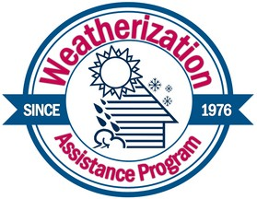
Weatherization

PO Box 40
204 S Walnut Suite B Ottawa, KS 66067
PH: 785-242-6413
Toll-Free: 1-888-833-0832
Fax: 785-242-1081
eckan.org

Please return the original bid forms (you may keep a copy for yourself)
Your mileage cost must be included in the bid. This is not added separately.

CIRCLE THE COUNTIES YOU WILL PROVIDE WEATHERIZATION SERVICES FOR:

Allen | Anderson | Bourbon | Chase
Coffey | Douglas | Franklin | Greenwood
Johnson | Linn | Lyon | Miami
Morris | Osage | Woodson | Wyandotte
Company Name

Agent

Address

City, State, Zip Code

Phone Number

Fax Number

E-mail Address

Signature of person completing bid.

Printed name of person completing bid.

Mission:

Vision:
ECKAN builds connections and provides program services in East Central Kansas to support the stability, health, and engagement of low-income individuals and families.

Taking intentional actions to show others we care.
Serving Allen, Anderson, Bourbon, Chase, Coffey, Douglas, Franklin, Greenwood, Johnson, Linn, Lyon, Miami, Morris, Osage, Woodson, and Wyandotte Counties.
EEO/EOP

